Lớp 4 - Kiểm tra cuối kỳ II | Sách Mềm
Toggle navigation
- Giới thiệu
- Sách mềm
- Đề kiểm tra
- Tin tức
- Hướng dẫn
  - Sử dụng Sách Mềm
  - Facebook Sách Mềm
  - Hỏi đáp
  - Bài giảng mẫu
- Tran
  - Tài khoản
  - Thoát
- Đề kiểm tra
- Lớp 4
- Kiểm tra cuối kỳ II
Tạo đề khác
Tải âm thanh
In
Full name: ………………………………………..  Class: ……………………………………………… | ENGLISH LANGUAGE TEST  Time: 45 minutes
I. LISTENING
Task 1. Listen and tick . There is one example.

Example:
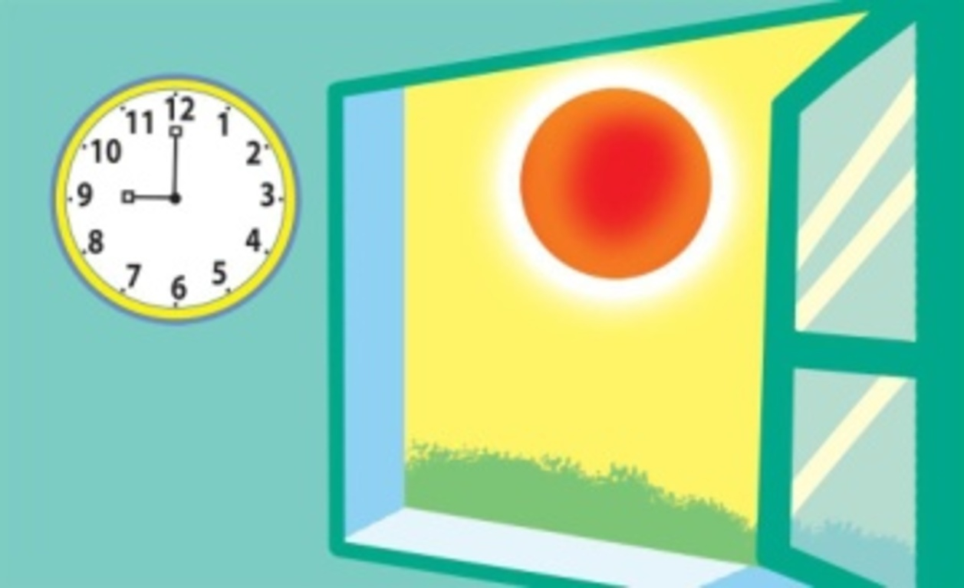  A. | 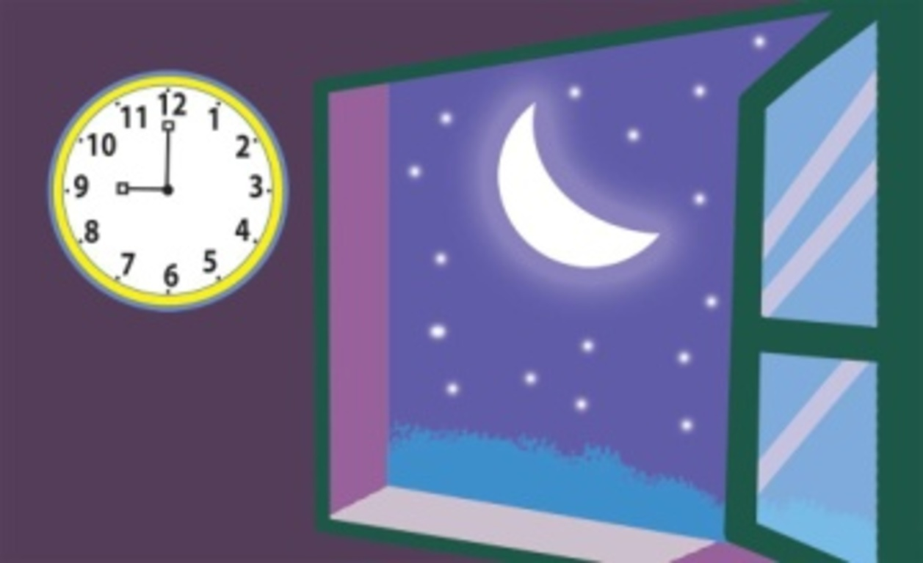  B.
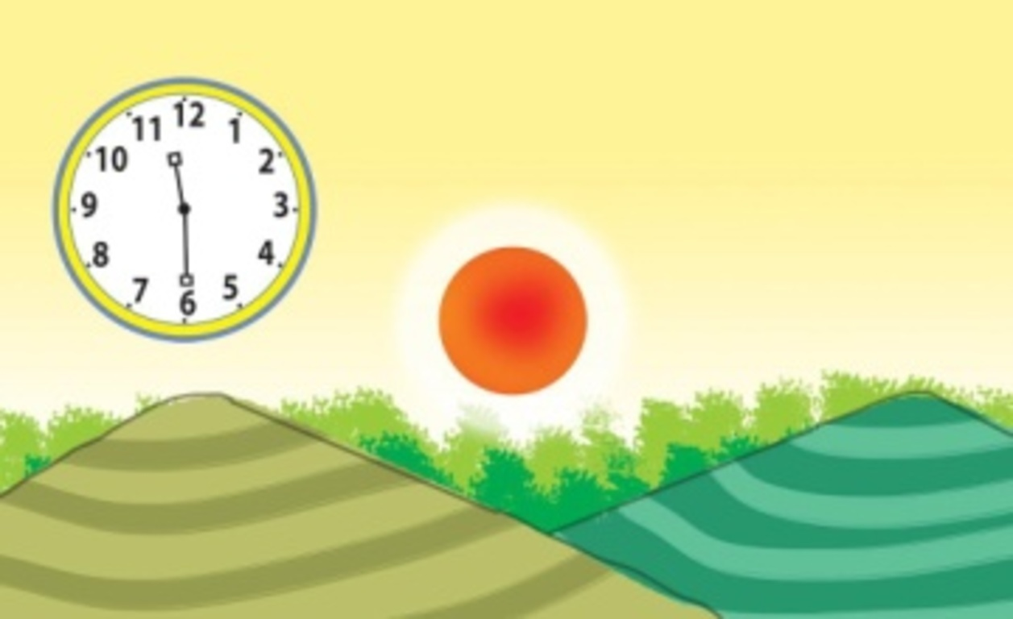  1. A. | 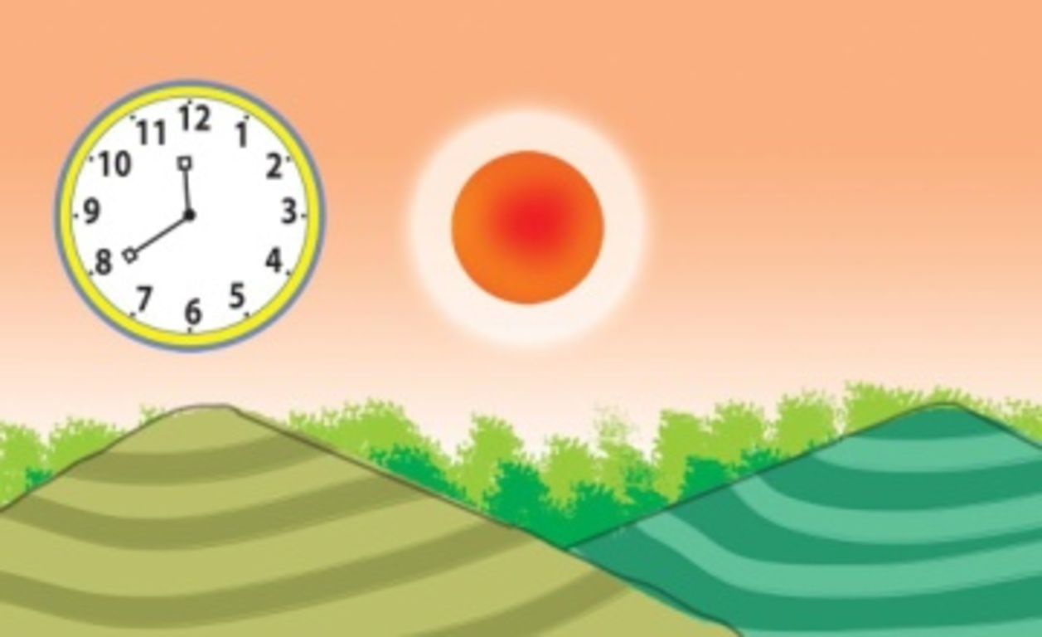  B.
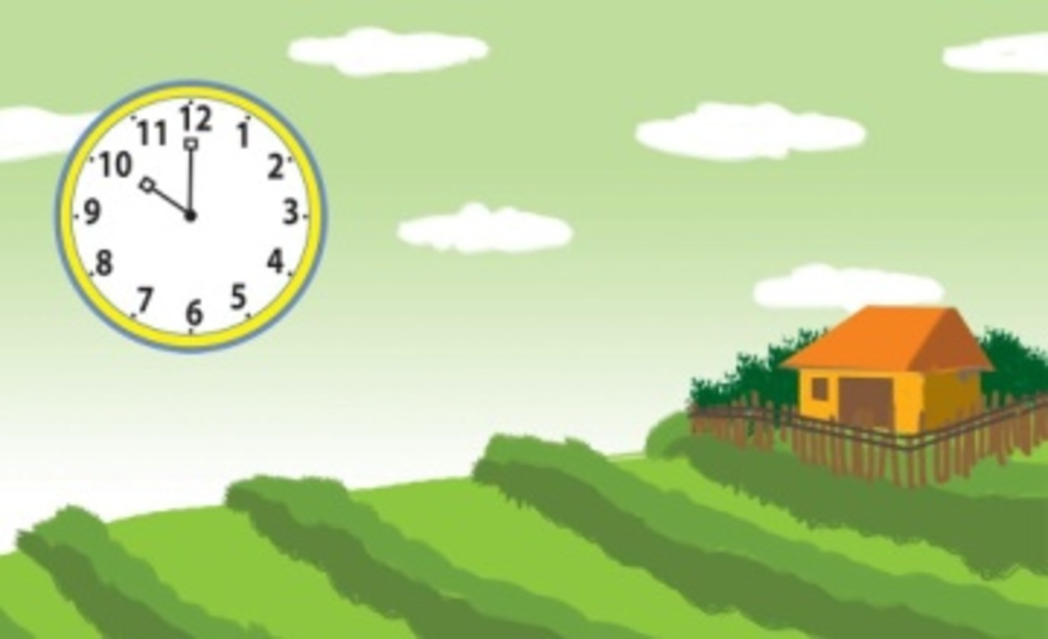  2. A. | 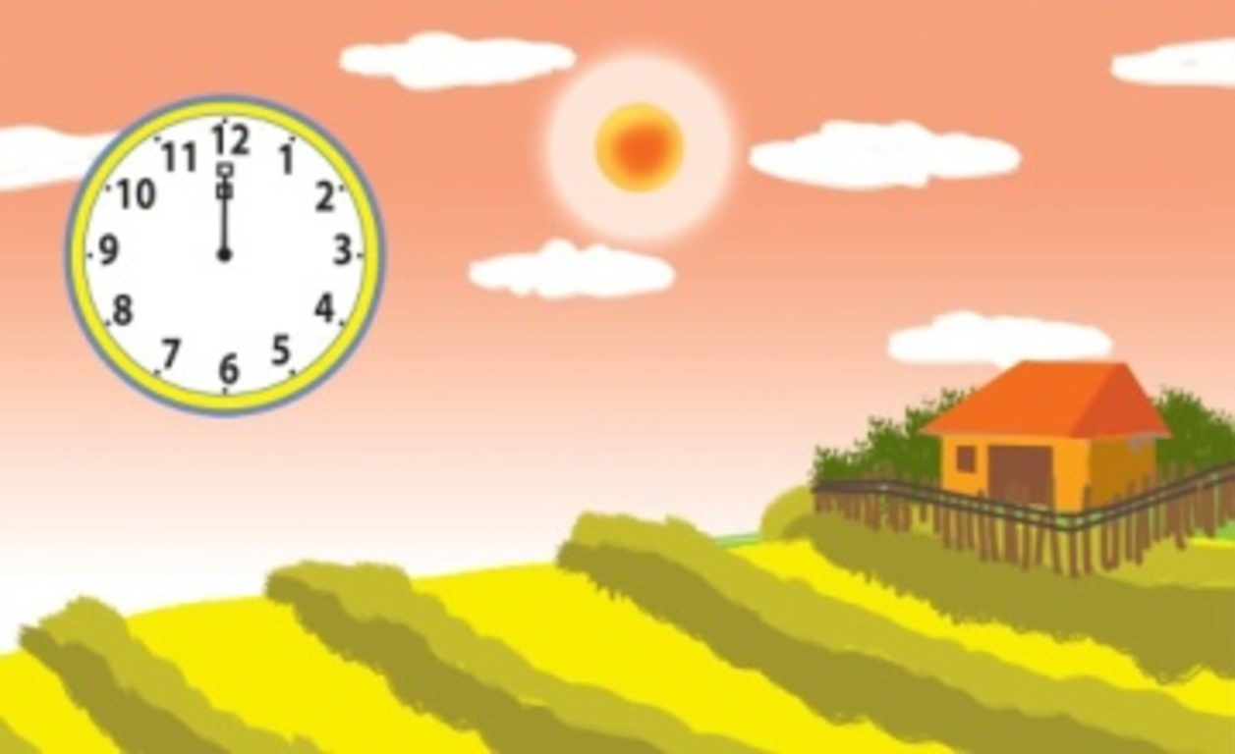  B.
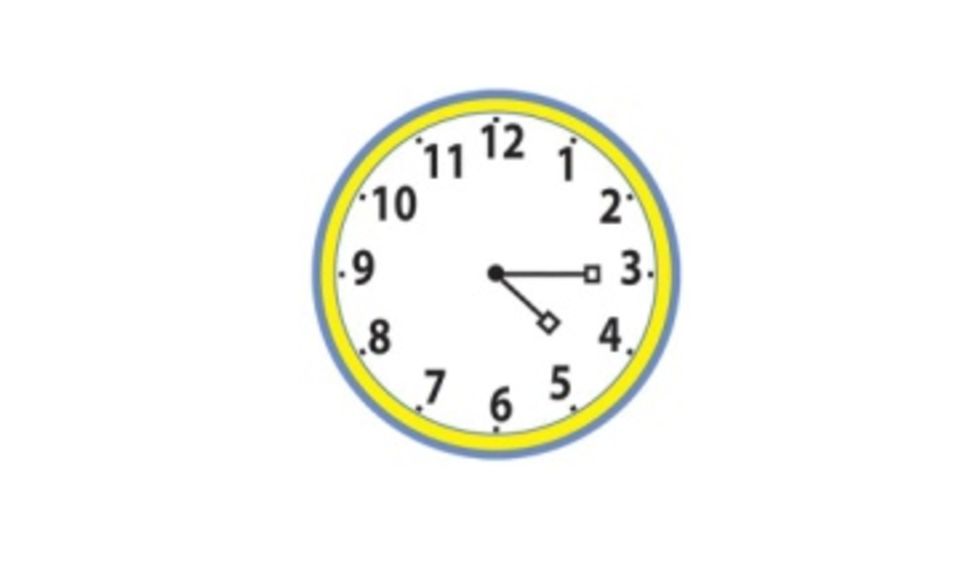  3. A. | 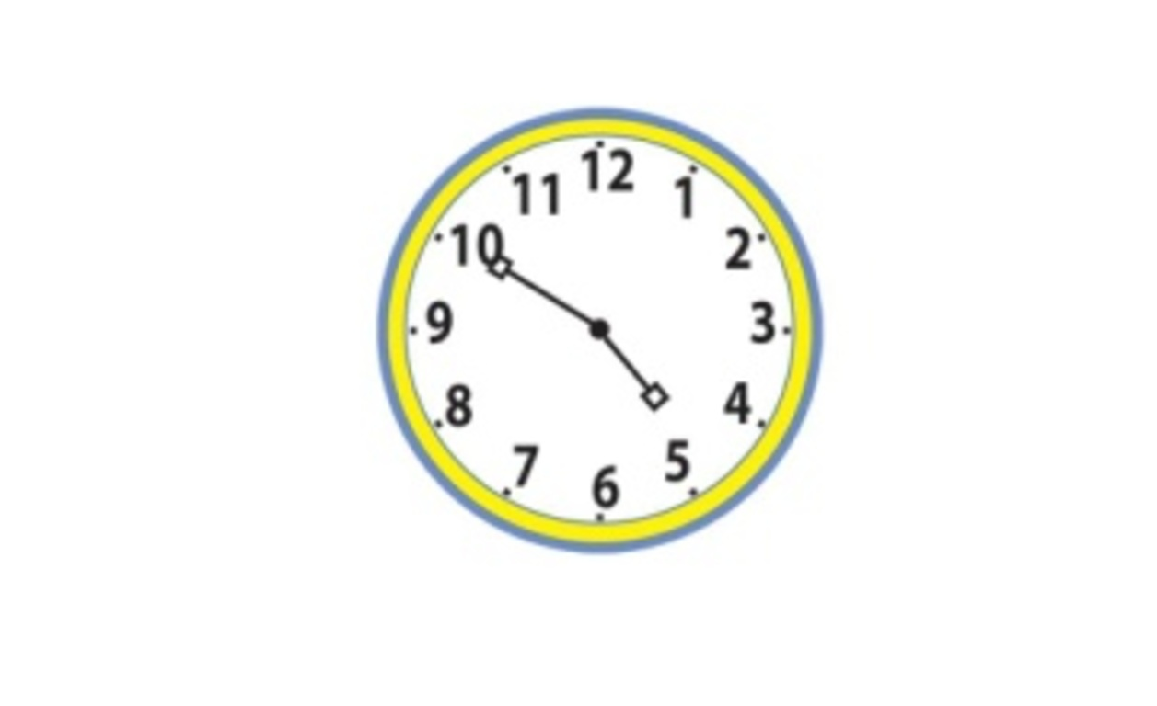  B.
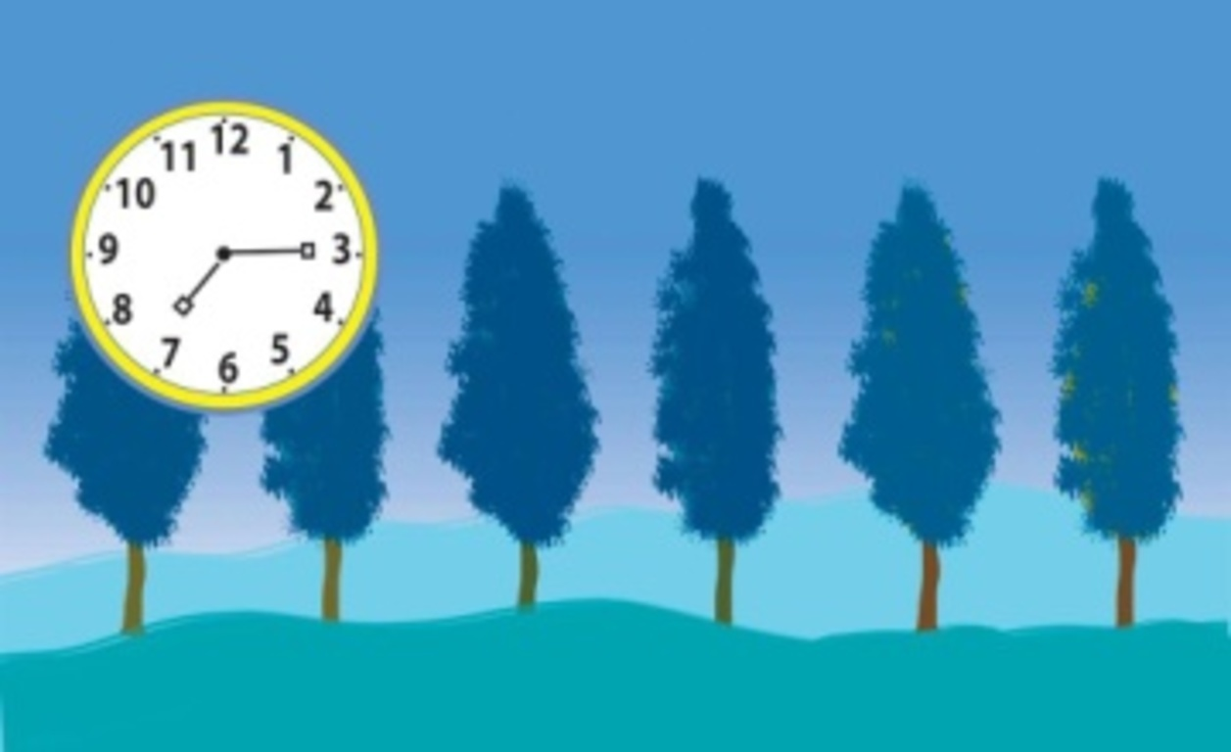  4. A. | 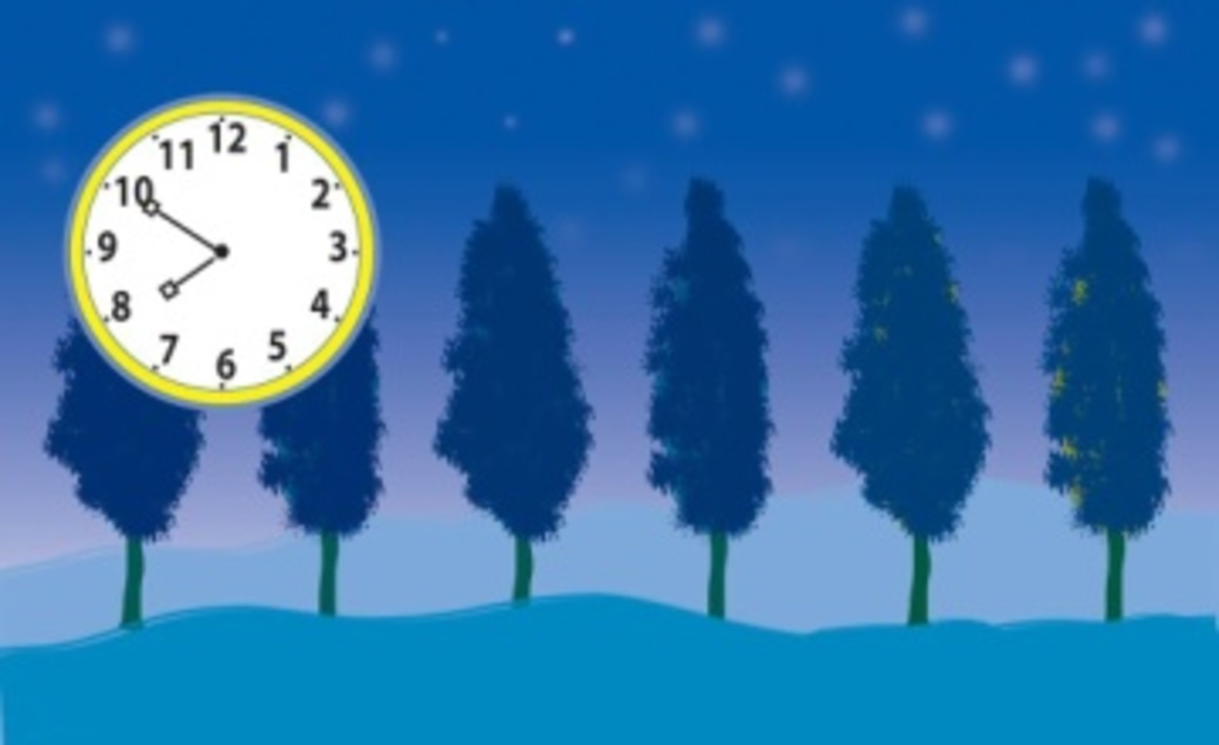  B.
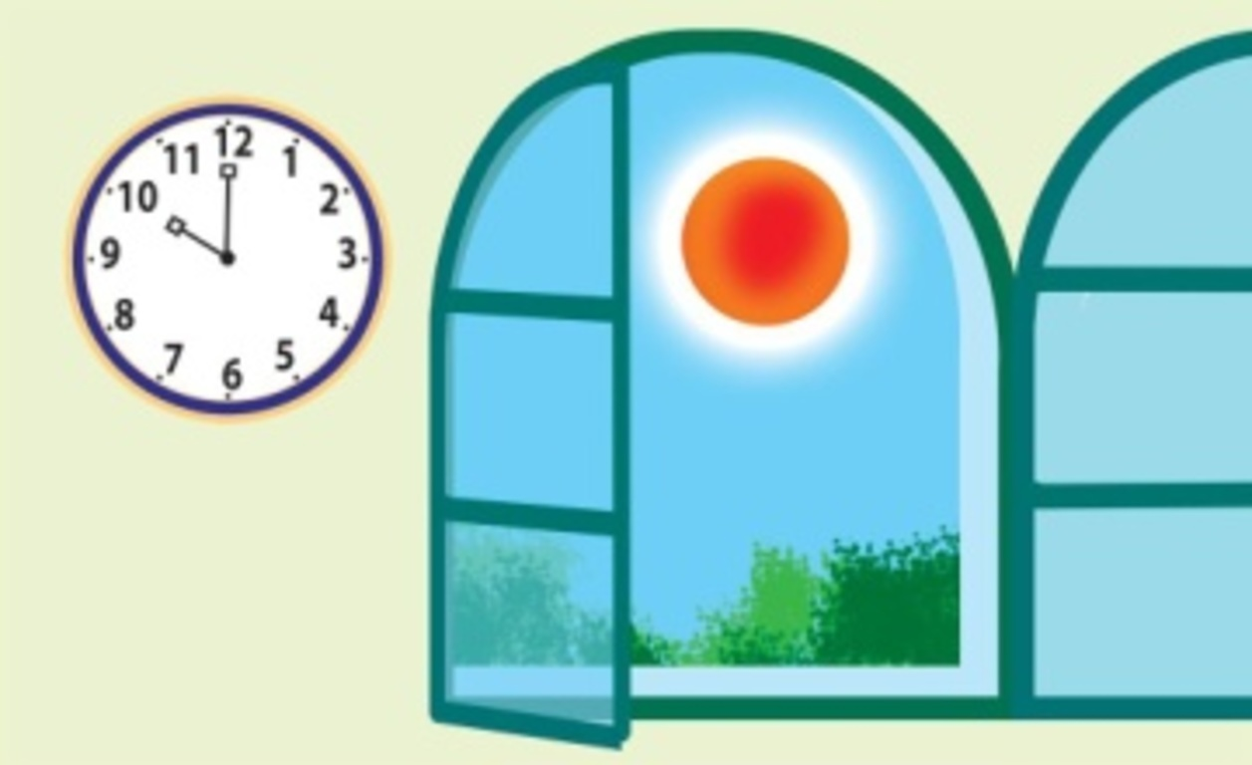  5. A. | 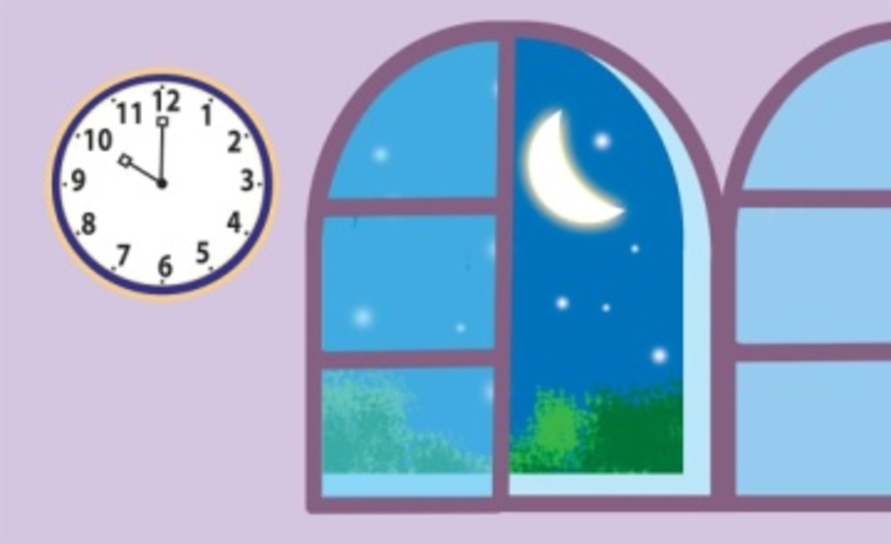  B.

Task 2. Listen and tick or cross . There are two examples.

Examples:
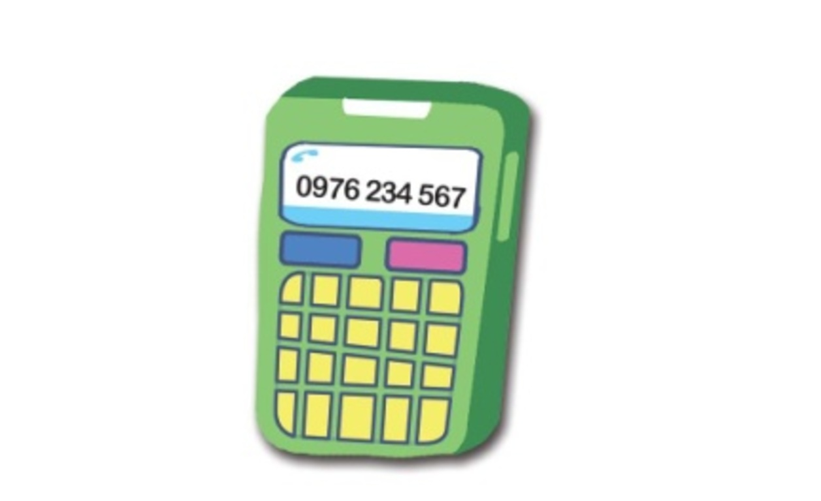  A. | 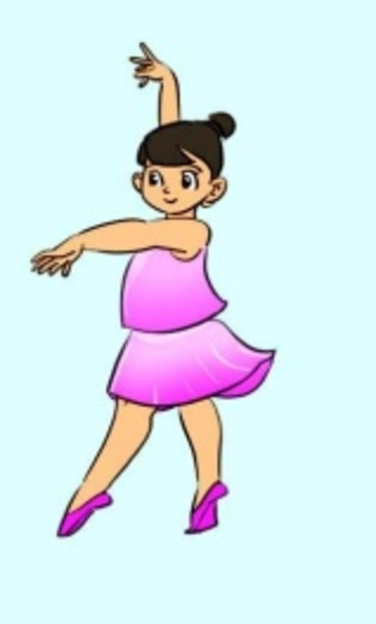  B.
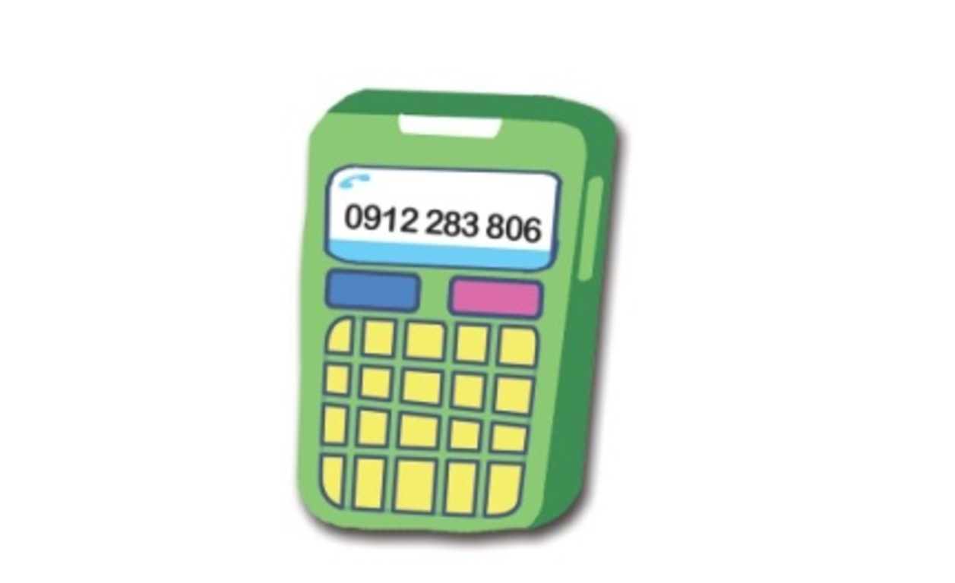  1. | 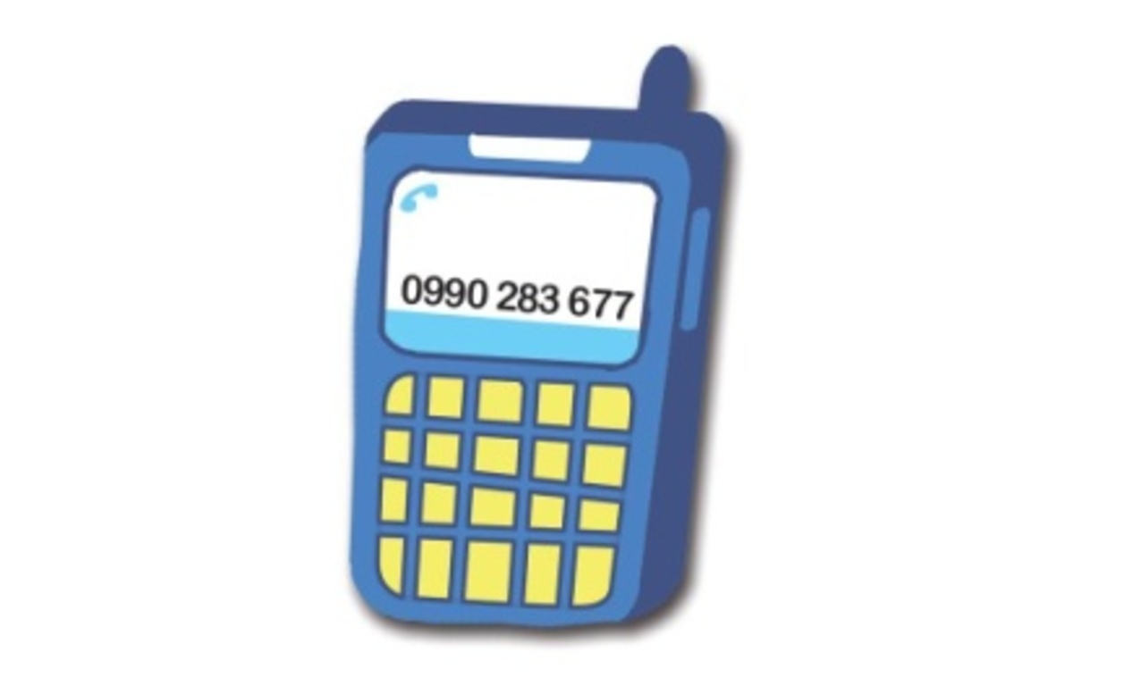  2. | 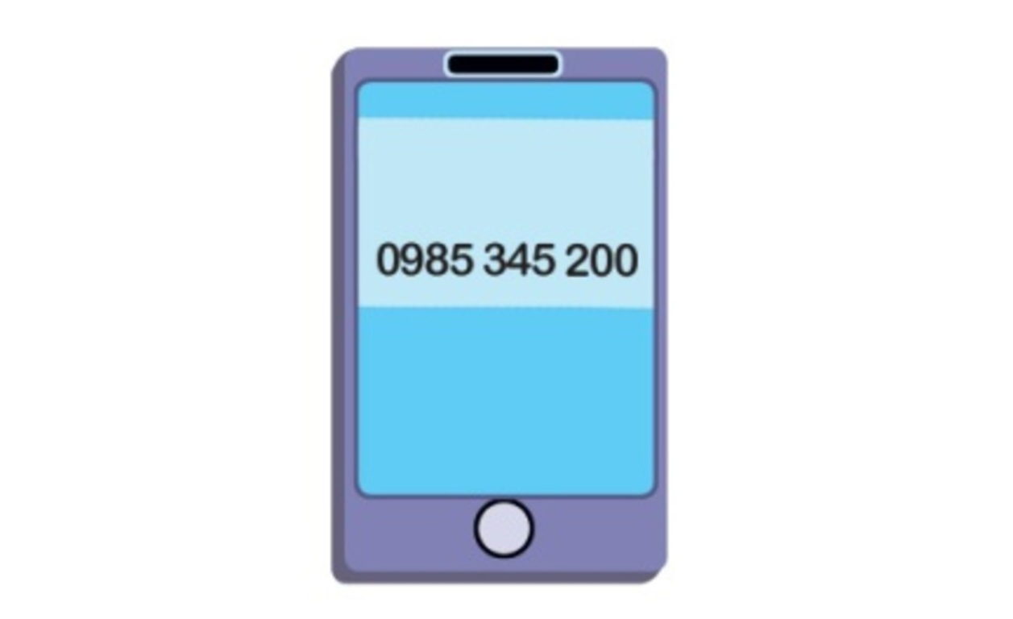  3.
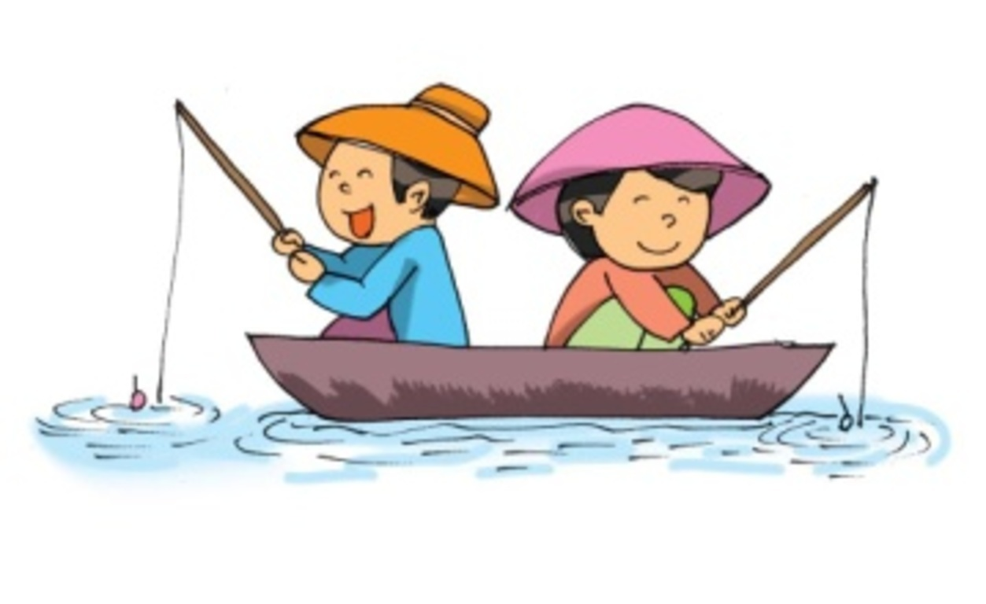  4. | 5.

Task 3. Listen and circle the correct answers. There is one example.

Example:
A. Tom is going to the supermarket. | B. Tom is going to the bookshop. | C. Tom is going to the pharmacy.
1. | A. They’re 60,000 dong. | B. They’re 70,000 dong. | C. They’re 80,000 dong.
2. | A. It’s 0912 283 804. | B. It’s 0912 283 805. | C. It’s 0912 283 809.
3. | A. He agrees to go swimming. | B. He agrees to go fishing. | C. He agrees to go dancing.
4. | A. She wants to see the monkeys. | B. She wants to see the bears. | C. She wants to see the elephants.
5. | A. He’s going to swim in the sea. | B. He’s going to play in the sun. | C. He’s going to eat seafood.

II. READING AND WRITING
Task 1A. Read and tick or cross . There are two examples.

Examples:
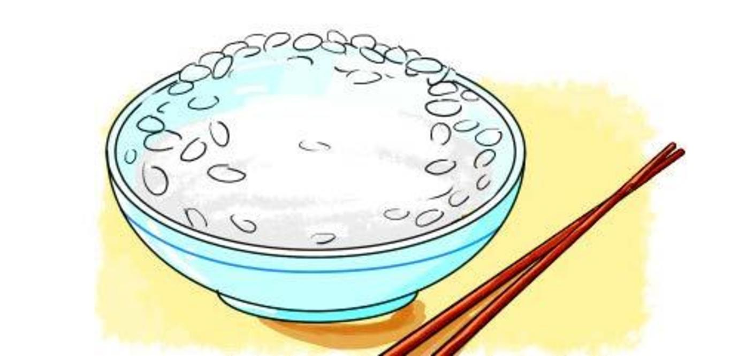  A. My favourite food is rice. | 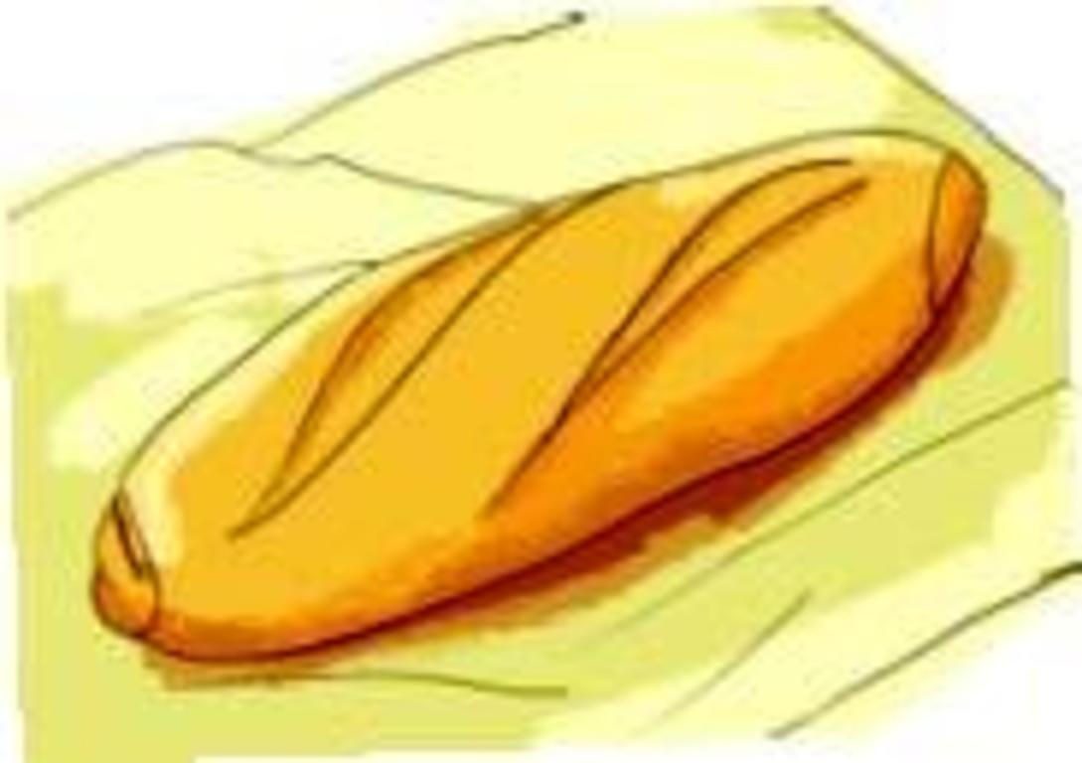  B. My favourite drink is orange juice.
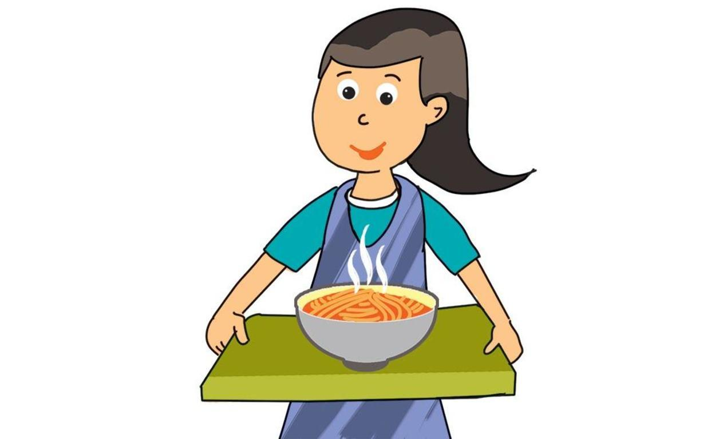  My favourite food is noodles.  1. | 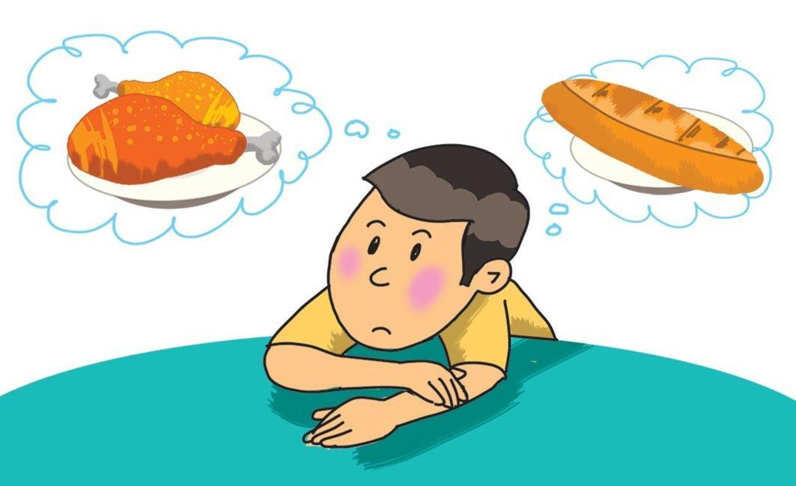  My younger brother likes bread and milk.  2.
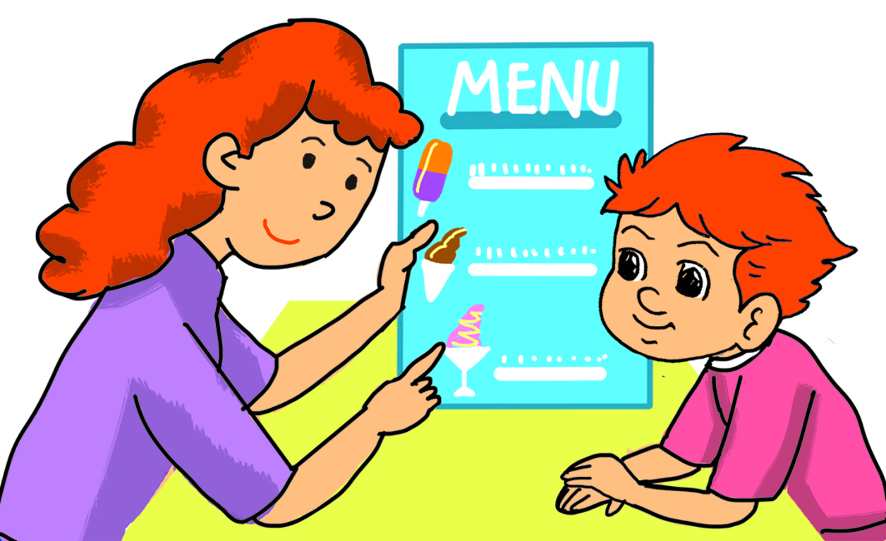  Would you like some ice cream, Tony?  3. | 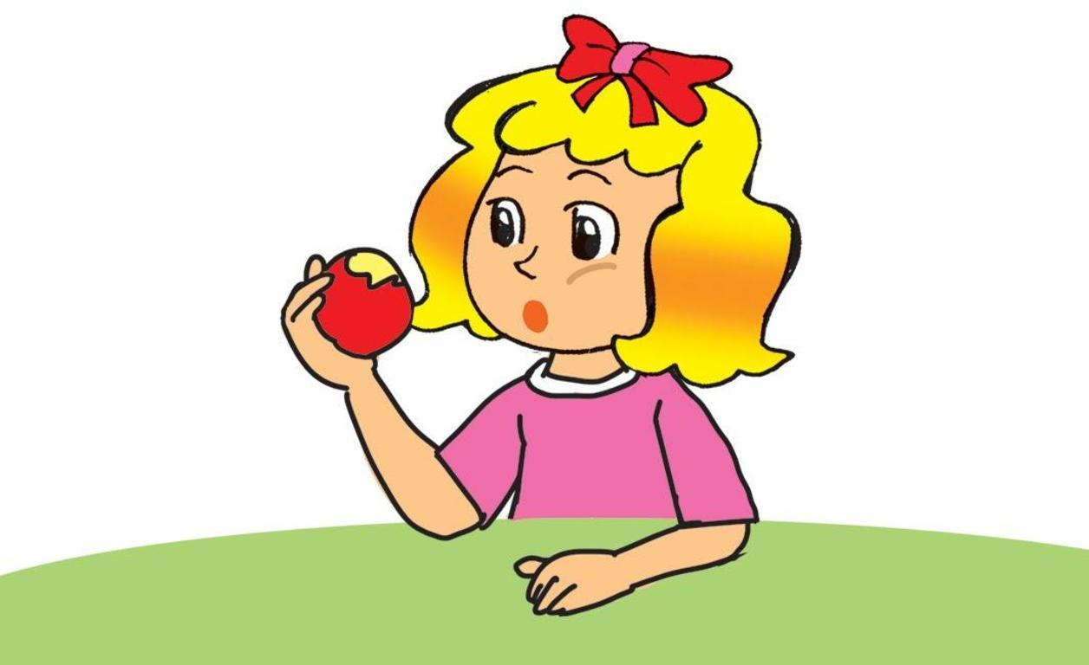  My favourite food is chicken.  4.
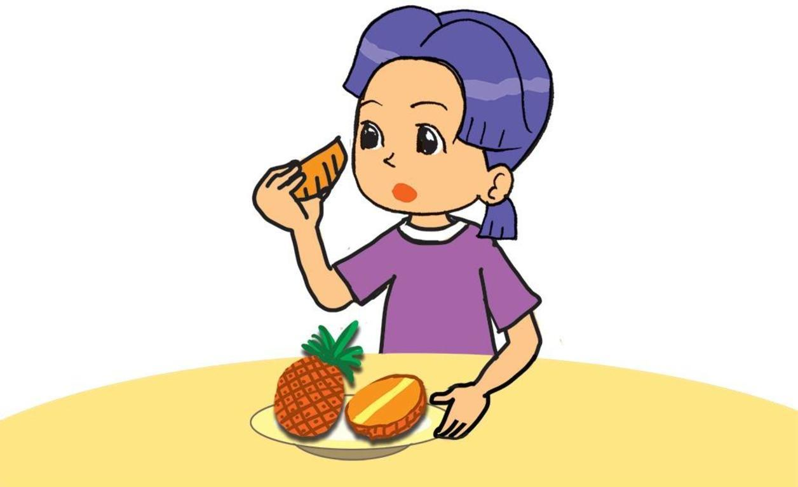
My favourite fruit is pineapple.
5.

Task 2. Order the words. There is one example.

Example: go / the / to / let’s / zoo
Let’s go to the zoo.
1. busy / John / go / the / he’s / cinema / because / can’t / to
________________________________________________.
2. the / like / to / would / go / you / supermarket / to
________________________________________________?
3. to / want / go / they / gym / why / the / do / to
________________________________________________?
4. chocolate / Tom / buy / to / some / wants
________________________________________________.
5. something / buy / want / to / they / eat / to
________________________________________________.

Task 3. Read and complete the answers. There is one example (0).

John and Kate like going to the zoo in their free time. There are a lot of animals there. John likes bears because they look big and strong. Some bears can cycle and play with balls. Kate doesn’t like bears because they are scary. She likes monkeys very much because they can swing and do funny things. Some of them can also cycle and play with balls.
0. What do John and Kate like doing in their free time? – They like going to the zoo.
1. What are there at the zoo? - There are _____________.
2. What animal does John like? – He likes _____________.
3. What can some bears do – They can _____________.
4. Why doesn’t Kate like bears? – Because they’re _____________.
5. Why does she like monkeys? – Because they can _____________.

III. SPEAKING
Task 1. Look, point and say. There is one example.

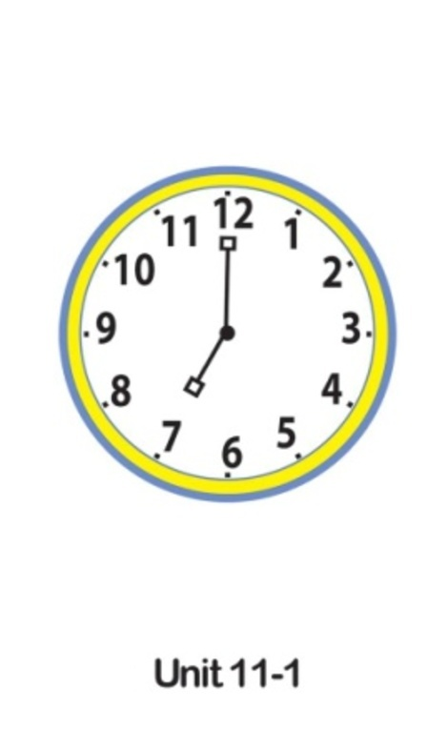 | 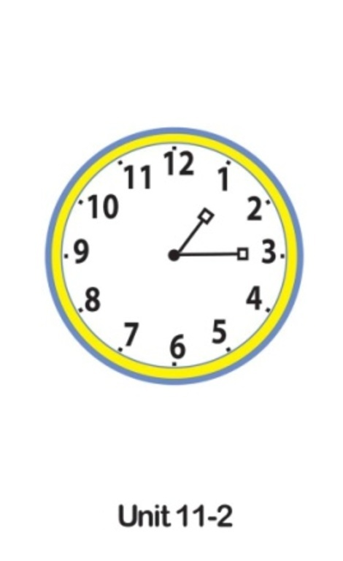 | 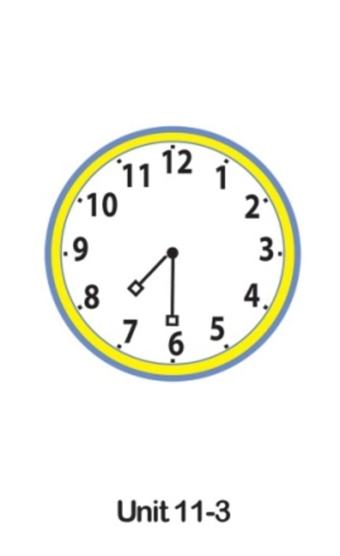
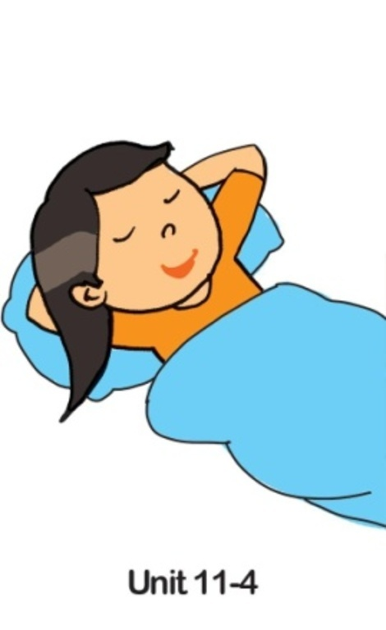 | 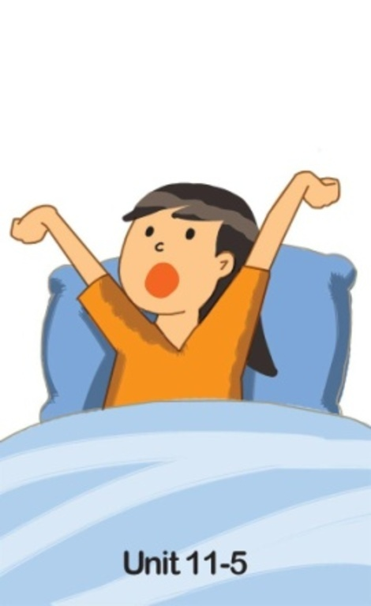 | 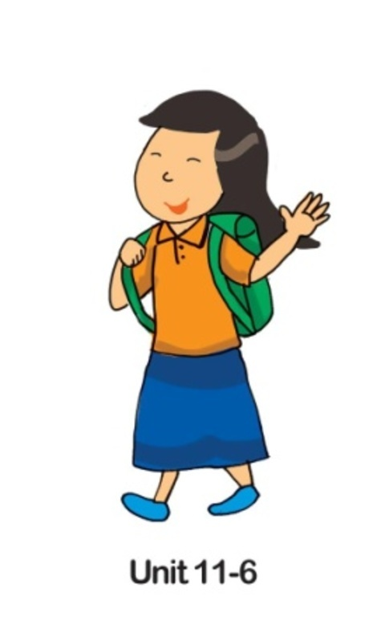 | 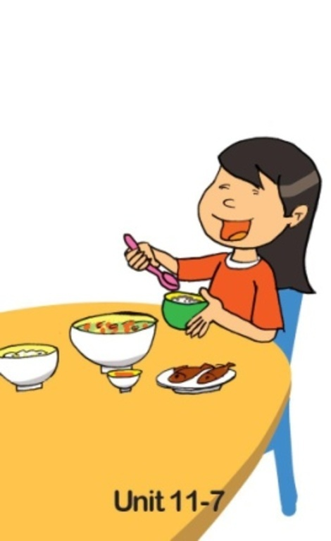

Task 1
Teacher does this:
Teacher says this:
Minimum response xpected from Student:
Back-up questions:
Arranges 6 cards (1-6) into 2 groups of time and action.
Look at the pictures. It’s seven o’clock.
Points to the cards respectively and says out the words:

Time: cards 1, 2, 3. Points to card 1 and says.
Now you look, point to the cards and say the time.
(Card 2) One fifteen
(Card 3) Seven thirty
What time is it? Is it + (time)?
Action: cards 4, 5, 6, 7. Points to card 4 and says.
She goes to bed.
Now you look, point to the cards and say the action.

(Card 5) She gets up.
(Card 6) She goes to school.
(Card 7) She has/eats breakfast/lunch/dinner.

What does she do?

Task 1. Look, listen and answer the questions. There is one example.

Hoa’s Day
1. Get up | 6.15
2. Have breakfast | 6.30
3. Go to school | 7.00
4. Have lunch | 11.00
5. Go home from school | 4.30 p.m.
6. Have dinner | 7.00 p.m.

Task 2
Teacher does this:
Teacher says this:
Minimum response expected from Student:
Back-up questions:

Shows the cue card.
Asks S to read the card for one minute.
Look at the card. There is one example.
I ask: What time does Hoa get up?
You answer: At six fifteen.
Or
I ask: What does Hoa do at six fifteen?
You answer: She gets up.
Now answer the questions:
Looks at the card.
Listens to questions and answers.

What time does Hoa have breakfast?
(She has breakfast) at six thirty.
What time? Look at this. (T points to the time in the cue card.)

What time does Hoa go to school?
(She goes to school) at seven o’clock.

What time does Hoa have lunch?
(She has lunch) at eleven o’clock.

What does she do at four thirty in the afternoon?
She goes home (from school).
Look. What can you see? Does she go home? (T points to the action in the cue card.)

What does she do at seven o’clock in the evening?
She has dinner.

Task 1. Let’s talk (Role play).

1. Greets (Say Hello to) the teacher.
2. Says why he/she wants to go to the zoo and what animal(s) he/she wants to see.
3. Says about the prices of his/her clothes.
4. Asks the teacher about his/her phone number.
5. Says where he/she is going this summer and what he/she is going to do.

Task 3 | Teacher does this: | Teacher says this: | Minimum interaction expected from S: | Back-up questions:
 | Shows the cue card. | Now you read the card. Then talk to me. | Sample conversation:  S: Good morning/afternoon Mr/Ms… | Say Hello to me, please.
 | Takes part in the conversation. |  | T: Hi, (S’s name) why do you want to go to the zoo in your free time?  S: Because I want to see ….  T: What animal(s) do you want to see?  S: I want to see… | Do you want to see monkeys? Why?
 |  |  | T: How much is/are your (clothes)?  S: It’s/They’re … dong. And you have a nice mobile phone. What’s your phone number?  T: It’s …(phone number). Tell me where you are going this summer. What are you going to do?  S: I’m going to …. | How much is/are your T-shirt?/blouse?/shoes?  Do you know my phone number? Ask me about my phone number.  Where are you going this summer? What are you going to do? Are you going to the beach with your friends?/family? Are you going to stay in the hotel?/swim in the sea? …
– The end –
manual page break

Đáp án
I. LISTENING
Task 1. Listen and tick . There is one example.
Key: 1. A 2. B 3. A 4. B 5. B
Hello. This is Tieng Anh 4. Unit 11. Listening Test.
Task 1. Listen and tick. There is one example.
(G): It’s nine a.m.
(G): It’s nine a.m.
Can you see the tick? This is an example. Now you listen and tick the box.
1. (B) It’s eleven thirty a.m.
2. (G) It’s noon.
3. (G) It’s four fifteen p.m.
4. (G) It’s seven fifty p.m.
5. (G) It’s ten p.m.
Now listen again.
That is the end of Task 1.
Task 2. Listen and tick or cross . There are two examples.
Key: 1. 2. 3. 4. 5.
Task 2. Listen and tick or cross. There are two examples.
A.
(B): What’s your phone number?
(G): It’s 0976 234 567.
(B): What’s your phone number?
(G): It’s 0976 234 567.
Can you see the tick?
B.
(B): Would you like to go skating?
(G): Yes, I’d love to.
(B): Would you like to go skating?
(G): Yes, I’d love to.
Can you see the cross? These are two examples.
Now you listen and tick or cross.
1.
(B): What’s your phone number?
(G): My phone number’s 0912 154 465.
2.
(B): What’s his phone number?
(G): It’s 0990 283 667.
3.
(B): What’s her phone number?
(G): It’s 0985 345 200.
4.
(B): Would you like to go fishing?
(G): Yes, I’d love to.
5.
(B): Would you like to go dancing?
(G): Yes, I’d love to.
Now listen again.
That is the end of Task 2.
Task 3. Listen and circle the correct answers. There is one example.
Key: 1. B 2. C 3. A 4. C 5. B
Task 3. Listen and circle the correct answers. There is one example.
(G): Hi Tom. Where are you going?
(B): I’m going to the supermarket.
(G): Going to the supermarket?
(B): Yes, I want to buy some food.

(G): Hi Tom. Where are you going?
(B): I’m going to the supermarket.
(G): Going to the supermarket?
(B): Yes, I want to buy some food.
Can you see the circled answer? This is an example. Now you listen and circle.
1.
(B): Excuse me. Can I have a look at the white shoes?
(W): Sure. Here you are.
(B): How much are they?
(W): They’re 70,000 dong
2.
(B): What’s your phone number, Jane?
(G): It’s 0912 283 809.
(B): Sorry?
(G): It’s 0912 283 809.
(B): Thank you.
3.
(G): Would you like to go skating, Tom?
(B): Sorry, I can’t. I can’t skate.
(G): What about going swimming? Would you like to go swimming?
(B): Yes, I’d love to.
4.
(G): Are you free now, Bob?
(B): Yes, I am.
(G): Let’s go to the zoo.
(B): Why do you want to go there?
(G): Because I want to see the elephants.
(B): OK. Let’s go.
5.
(G):Where are you going this summer, David?
(B): I’m going to Ha Long Bay.
(G): What are you going to do there?
(B): I’m going to play in the sun.
Now listen again.
That is the end of Task 3.
II. READING AND WRITING
Task 1A. Read and tick or cross . There are two examples.
Key: 1. 2. 3. 4. 5.
Task 2. Order the words. There is one example.
Key:
1. John can’t go to the cinema because he’s busy.
2. Would you like to go to the supermarket?
3. Why do they want to go to the gym?
4. Tom wants to buy somechocolate.
5. They want to buy something to eat.
Task 3. Read and complete the answers. There is one example (0).
Key:
1. a lot of animals
2. bears
3. cycle and play with balls
4. scary
5. swing and do funny things
×Close

Report
Close
Submit
×

Giới thiệu Hướng dẫn
Đang tạo file..

