Tien Dong Primary School  Class: 4...........  Full name: ........................................... | The last term test 2020 - 2021  Subject: English  Time: 40 minutes
Marks | Listening |  |  | Writing - Reading |  |  | Speaking |  | Total
 | Q1 | Q2 | Q3 | Q4 | Q5 | Q6 | Q7 | Q8
I. LISTENING
Question 1. Listen and tick . 2pts

1. | A. | 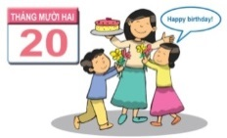  B.
2. | 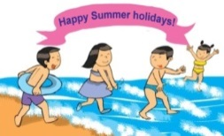  A. | B.
3. | A. | 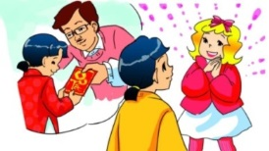  B.
4. | 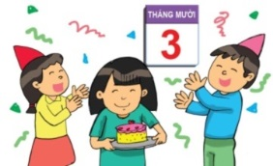  A. | 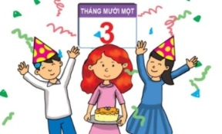  B.

Question 2. Listen and tick or cross . (1pt)

1. | 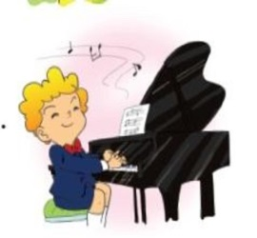  2. | 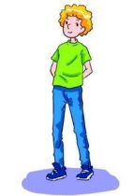  3.
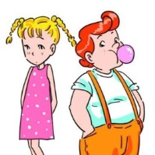  4. | 5.

Question 3. Listen and tick the correct pictures. (1pt)
1. What do the girls like doing?
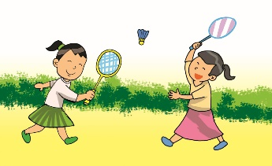  A. | B. | 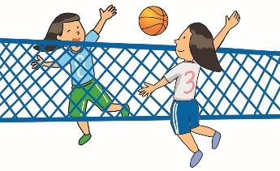  C.
2. What do the boys love doing?
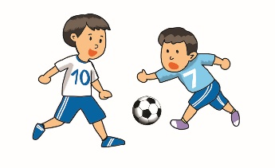  A. | 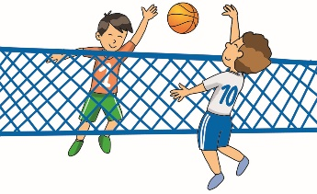  B. | 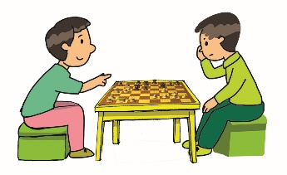  C.
3. What do some boys and girls like doing?
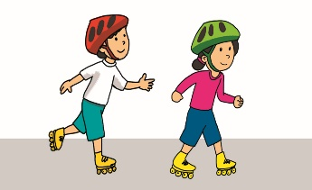  A. | 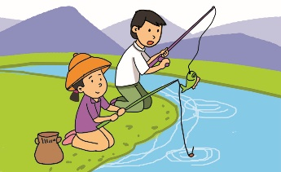  B. | 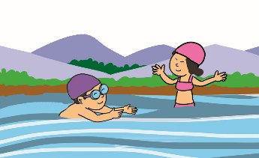  C.
4. How does Jane love taking photographs?
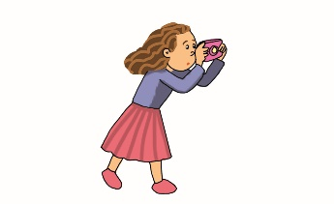  A. | B. | C.
II. READING AND WRITING
Question 4. Look and write. 1pt
1. hidrclne →
_ _ _ _ _ _ _ _’s Day
2. trodoc → _ _ _ _ _ _
3. febe → _ _ _ _ | 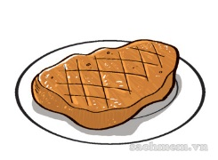
4. lepehnats→ _ _ _ _ _ _ _ _ _ | 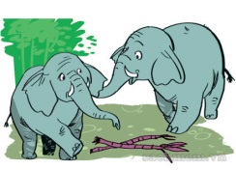

Question 5. Order the words. 1pt
1. like / some / sister / milk / would/ my
___________________________________________.
2. likes / because / they / kangaroos / Nam / fast/ are
___________________________________________.
3. taller / my / than / brother/ me/ is /
___________________________________________.
4. summer / are / this / you / holiday / where / going
___________________________________________?
Question 6. Read and complete the answers. There is one example (0). 2 pt
Jim and Mary like going to the zoo in their free time. There are a lot of animals there. Jim likes bears because they look big and strong. Some bears can cycle and play with balls. Mary doesn’t like bears because they are scary. She likes monkeys very much because they can swing and do funny things. Some of them can also cycle and play with balls.
0. What do John and Kate like doing in their free time? – They like going to the zoo.
1. What are there at the zoo? - There are _____________.
2. What animal does Jim like? – He likes _____________.
3. What can some bears do – They can _____________.
4. Why doesn’t Mary like bears? – Because they’re _____________.
III. SPEAKING
Question 7. Look, point and say. (1pt)
Question 8. Answer the questions(1pt)
________The end________

Đáp án
I. LISTENING
Question 1. Listen and tick . There is one example. 2 pts
Key: 1. A 2. B 3. A 4. A
Question 2. Listen and tick or cross . There are two examples. 1pt
Key: 1. 2. 3. 4. 5.
Question 3. Listen and tick the correct pictures. There is one example (0).1pt
Key: 1. C 2. A 3. C 4. B
II. READING AND WRITING
Question 4. Look and write. There is one example. 1pt
Key: 1. Children’s Day 2.doctor 3. beef 4. elephants
Question 5. Order the words. There is one example. 1pt
Key:
1. What does your father do?
2. My sister would like some milk.
3. Nam likes kangaroos because they are fast.
4. My brother is taller than me.
5. Where are you going this summer holiday?
Question 6. Read and complete the answers. There is one example (0). 1 pt
- There are a lot of animals.
- He likes bears.
- They can cycle and play with balls.
- Because they are scary.

