Full name: ...............................................  Class: ...................................................... | ENGLISH LANGUAGE TEST  Time: 45 minutes
I. LISTENING
Task 1. Listen and tick . There is one example.

Example:
A. | B.

1. A. | 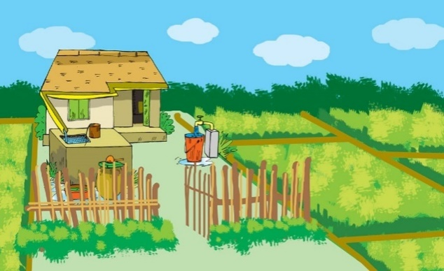  B.
2. A. | B.
3. A. | 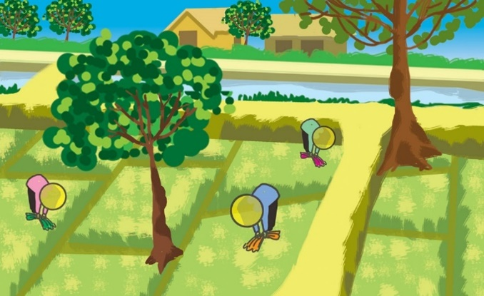  B.
4. A. | B.
5. A. | 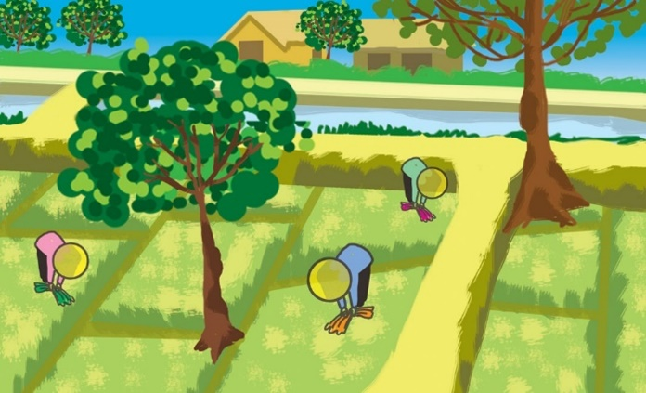  B.
Task 2. Listen and tick or cross . There are two examples.

Examples:
A. | B.

1. | 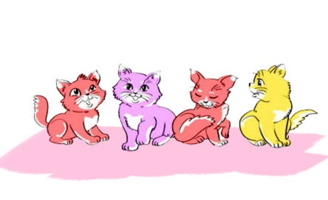  2. | 3.
4. | 5.

Task 3. Listen and number. The first picture is done for you.

Example:
 |  | 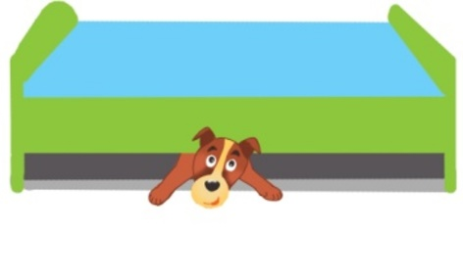
A. | B. | C.
 | 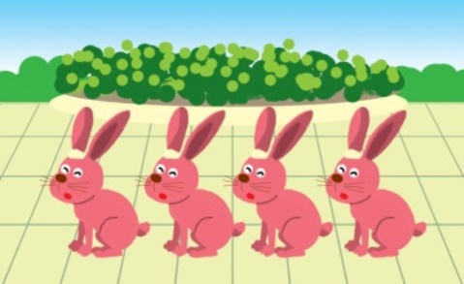
D. | E. | F.

II. READING AND WRITING
Task 1. Look and write. There is one example.
Example: randgei → r e a d i n g | 1. cgyncil → c_ _ _ _ _ _ | 2. kstinag → s_ _ _ _ _ _
3. pisngkip → s_ _ _ _ _ _ _ | 4. ngsngii → s_ _ _ _ _ _ | 5. wsimignm → s_ _ _ _ _ _ _
Task 2. Look and read. Tick or cross the box. There are two examples.
Examples:
A. There’s a pond. | B. There’s a gate in front of the house.

1. This is a house. | 2. There is a garden in front of the house. | 3. There isn’t a pond behind the house.

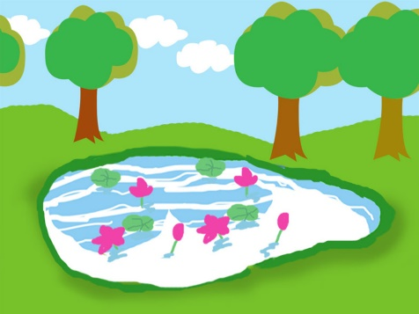  4. There’s a pond in the garden. | 5. The gate is blue.
Task 3. Read and complete. There is one example
cats | under | pets | the | dog | on

A: | Do you have any (0) pets?
B: | Yes, I do. I have a (1) _______ and two cats.
A: | Where’s (2) _______ dog?
B: | It’s here, (3) _______ the table.
A: | Where are the (4) _______?
B: | Let me see. Oh, they are (5) _______ the bed.
A: | Oh, they’re very nice.

